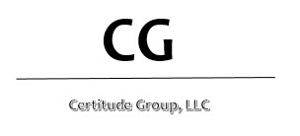

HEPATITIS B VACCINATION DECLINATION STATEMENT

I understand that due to my occupational exposure to blood or other potentially infectious materials (OPIM) I may be at risk of acquiring Hepatitis B virus (HBV) infection.

I have been given the opportunity to be vaccinated with Hepatitis B vaccine, at no charge to myself.

However, I decline the Hepatitis B vaccination at this time. I understand that by declining this vaccine, I continue to be at risk of acquiring Hepatitis B, a serious disease.

If in the future I continue to have occupational exposure to blood or other potentially infectious materials and I want to be vaccinated with Hepatitis B vaccine, I can receive the vaccination series at no charge to me.

____________________________ __________________________

Employee Printed Name Date

____________________________ __________________________

Employee Signature Employee Title